Assignment 9

import pandas as pd

import numpy as np

import matplotlib.pyplot as plt

import seaborn as sns

dataset = sns.load_dataset('titanic')

dataset.head()

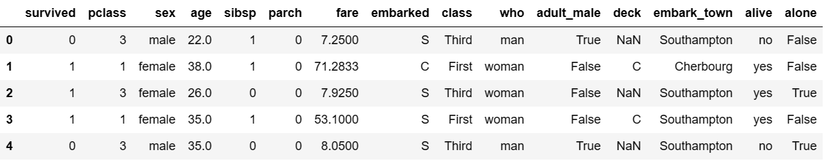

sns.countplot(dataset['survived']) plt.show()

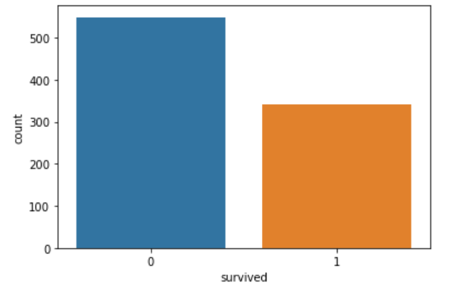

dataset['sex'].value_counts().plot(kind="pie", autopct="%.2f") plt.show()

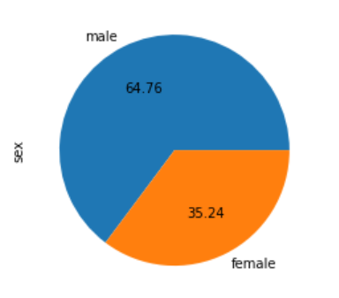

plt.hist(dataset['age'],bins=5) plt.show()

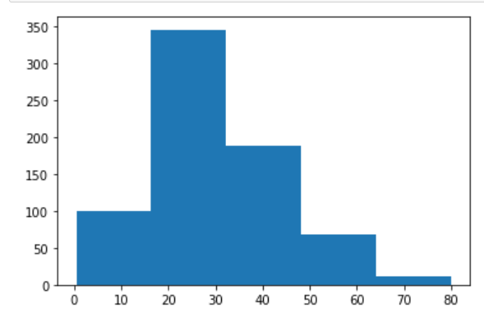

sns.distplot(dataset['age'])

plt.show()

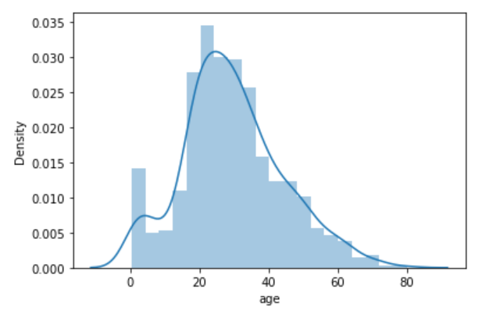

sns.barplot(dataset['pclass'], dataset['fare'], hue = dataset ["sex"])

plt.show()

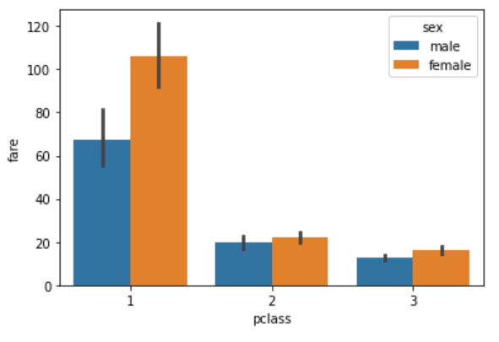

sns.boxplot(dataset['sex'], dataset["age"])

sns.boxplot(dataset['sex'], dataset["age"], dataset["survived"])

plt.show()

